USE CASE DIAGRAM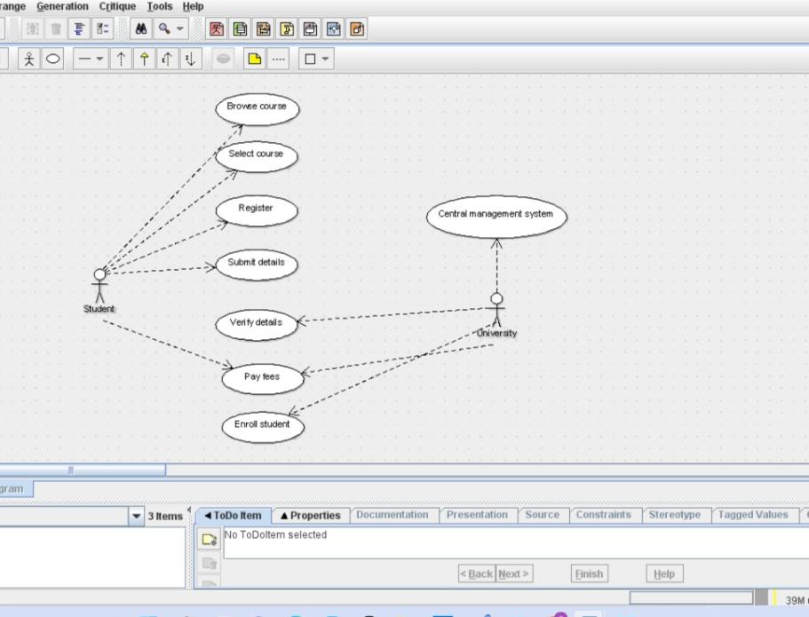

CLASS DIAGRAM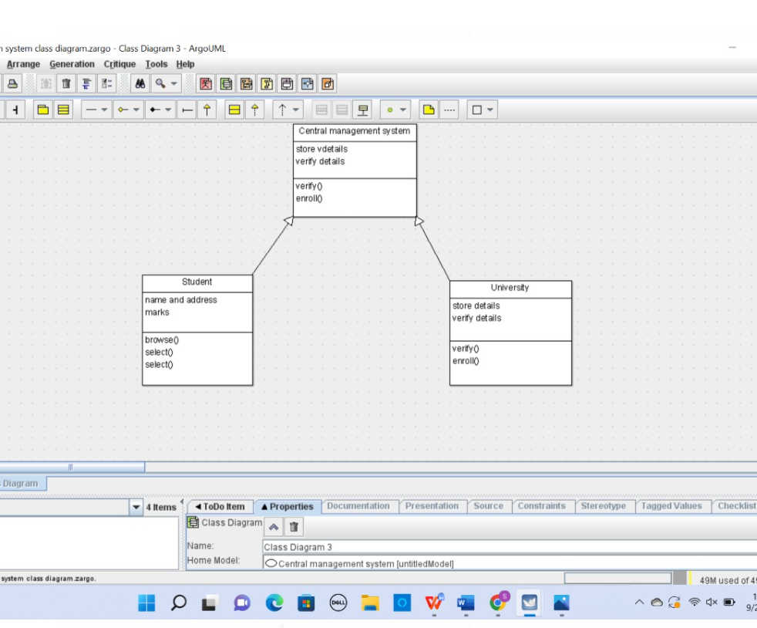

public class Central management {

private train name;

public passenger name;

public void reservation() {

}

public void cancellation() {

}

public void status() {

}

public void login() {

}

private void management() {

}

}

public class Passenger1 extends Central management {

public passenger name;

public passenger age;

public passenger phone number;

public void login() {

}

public void passenger1() {

}

public class Railway reservation system extends Central management {

private train number;

public train name;

public passenger name;

public void status() {

}

public void reservation() {

}

public void cancellation() {

}

public void railway reservation system() {

}

SEQUENCE DIAGRAM

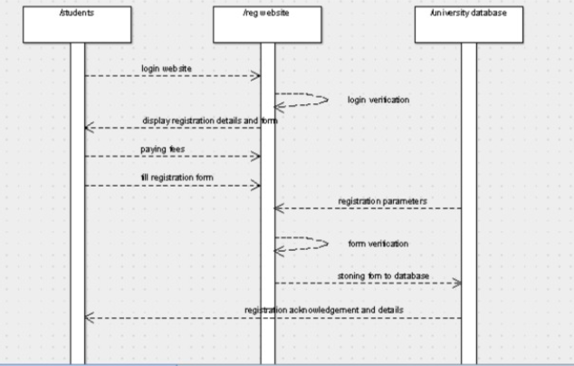

COLLABORATION DIAGRAM

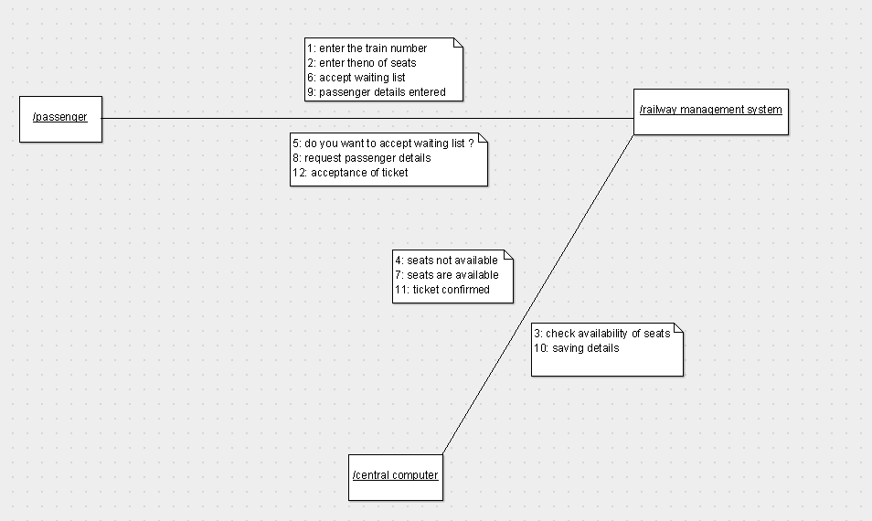

ACTIVITY DIAGRAM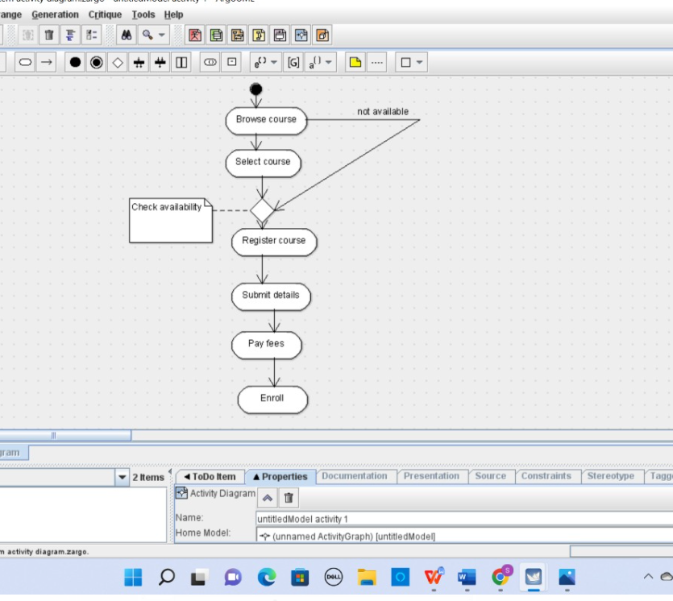

STATE CHART DIAGRAM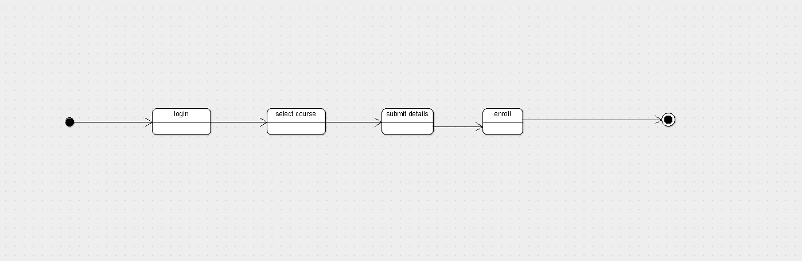

COMPONENT DIAGRAM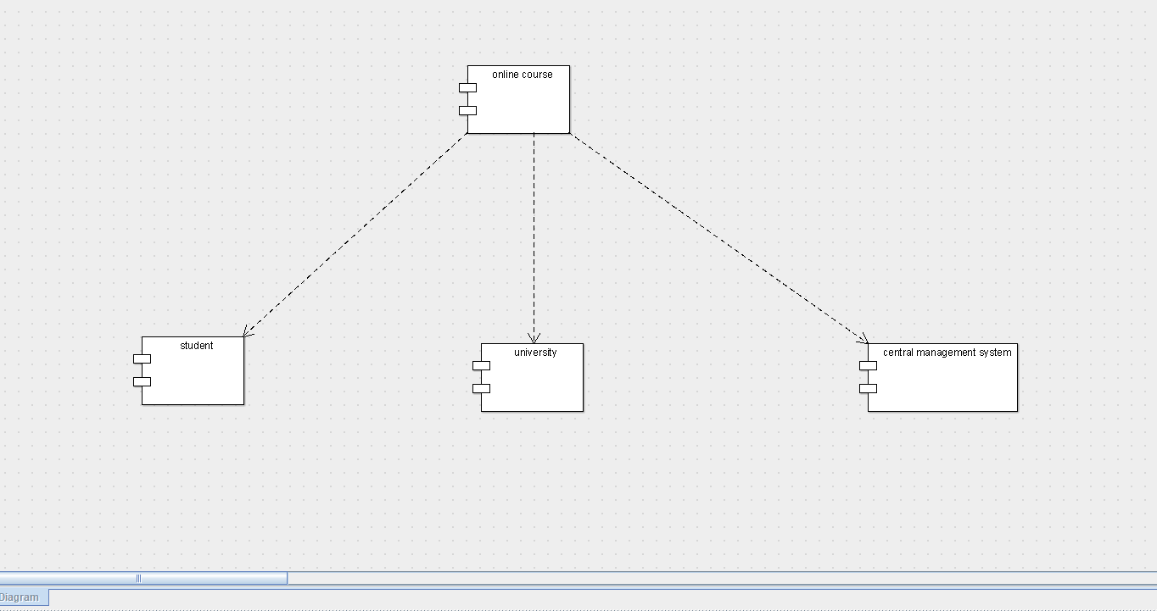

DEPLOYMENT DIAGRAM